Ardour set up on Mac 4

Flashing single amber on Midi interface seems to mean it’s not going to work

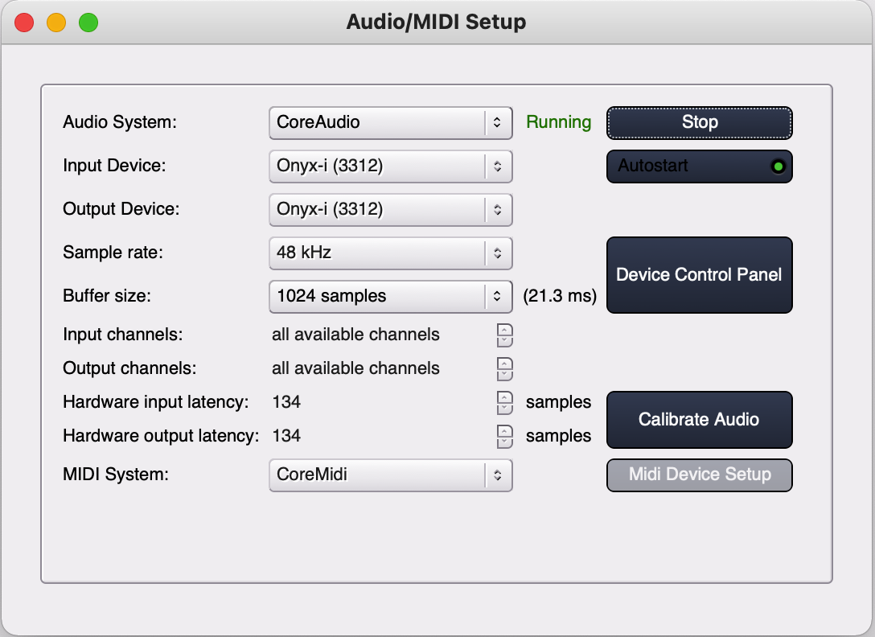

Core audio set up should show core midi

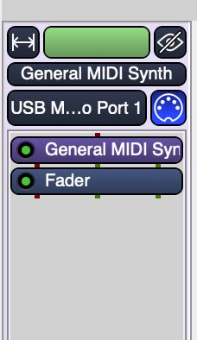

Blue means active – here USB port 1 is taking an input

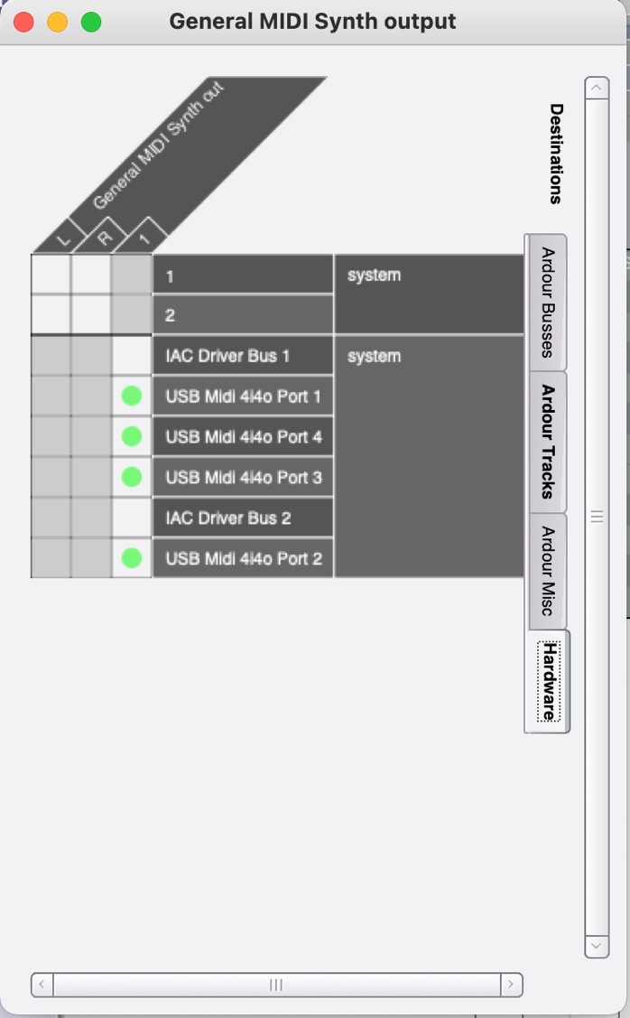

This is critical to send midi out to the interface – it is accessed by clicking on the synth name in the mixer and selecting inputs – nothing else is selected on any other tab

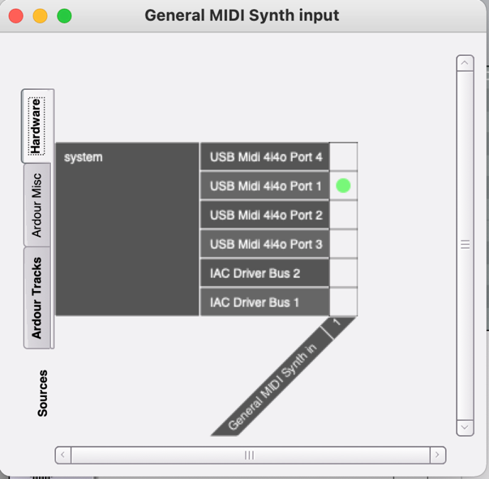

Input is more straight forward but I don’t understand the flash at the bottom – just select the input port

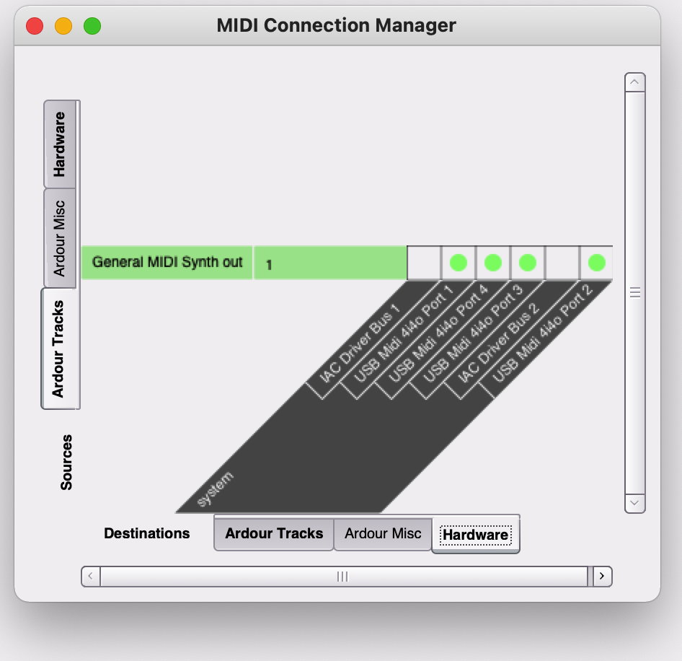

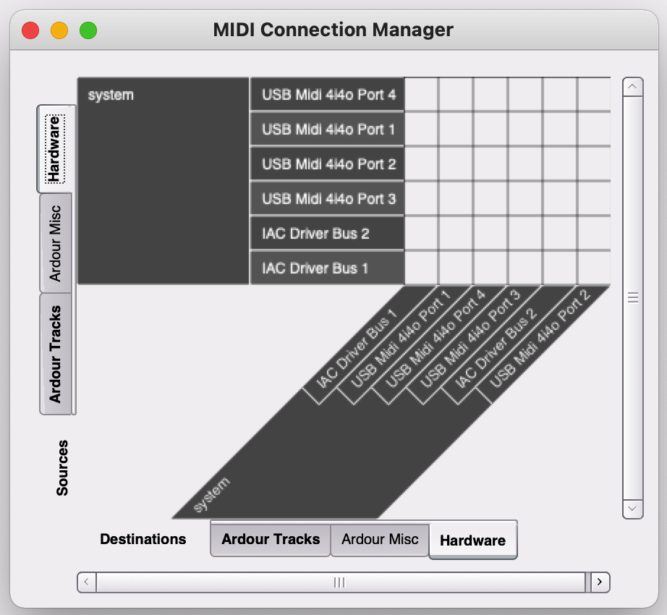

These two screens are confusing – beware creating a mess by not reading the tabs properly

